Assignment 4 worksheet

MPL CHAPTER 7 programMING PROJECTS

This ASSIGNMENT contains the following activities:

|  |  |
| --- | --- |
| Activity 4.1 | Choosing Your Programming Projects |
| Activity 4.2 | Submitting your Solution |

|  |  |
| --- | --- |
| Activity 4.1 | Choosing your Programming Project |
| Overview | In Activity 4.1, you choose your Programming Project. |

1. Review MyProgrammingLab Chapter 7, “Programming Projects” and choose one out of four projects:
2. A RainFall class (71115)
3. A two arguments Method (71116)
4. Quarterly Sales Statistics (73086)
5. Grade Book (73087)

**Note:**

* These 4 “Programming Projects” descriptions are included at the end of this Doccument (See Appendix).

|  |  |
| --- | --- |
| Activity 4.2 | Submitting Your Solution |
| Overview | In Activity 4.2, you submit your solution. |

1. After writing, compiling and running the programming project of your choice successfully (or partially). Take a screen shot of the Output by pressing Alt+Prt Scr and then paste it here (into your CISC190 - Assignment04_worksheet) file by pressing Ctrl+V.

**<< PASTE THE SCREEN SHOT HERE >>**

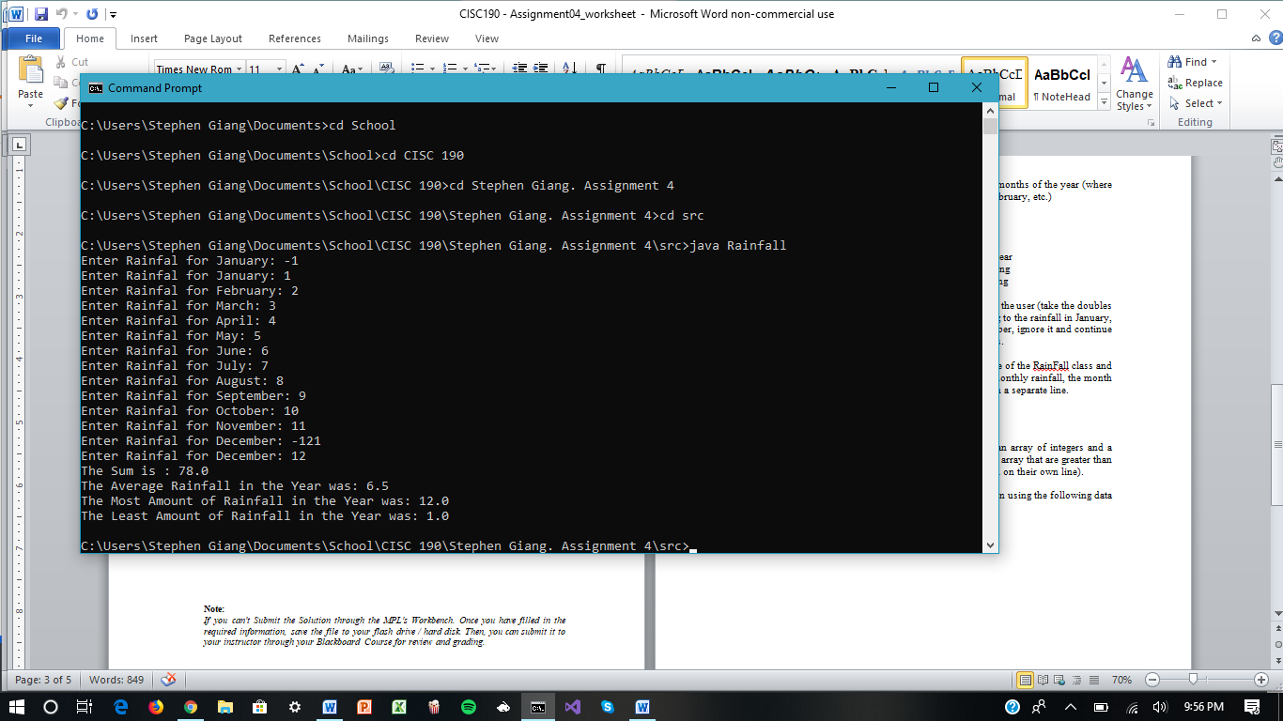

**Appendix**

1. **A RainFall class (71115)**

Write a RainFall class that has the following field:

• an array of doubles that stores the rainfall for each of the 12 months of the year (where the first index corresponds with January, the second with February, etc.)

The class should also have the following methods:

• a method that returns the total rainfall for the entire year

• a method that returns the average monthly rainfall for the year

• a method that returns the month with the most rain as a string

• a method that returns the month with the least rain as a string

Demonstrate the class in a program that takes 12 doubles from the user (take the doubles in the order of the months of the year, the first corresponding to the rainfall in January, etc.). Do input validation: if the user inputs a negative number, ignore it and continue asking them for input until you have 12 nonnegative doubles.

Once the user has given you all 12 doubles, create an instance of the RainFall class and call its methods, printing out the total rainfall, the average monthly rainfall, the month with the most rain, and the month with the least rain, each on a separate line.

1. **A two arguments Method (71116)**

In a program, write a method that accepts two arguments: an array of integers and a number n. The method should print all of the numbers in the array that are greater than the number n (in the order that they appear in the array, each on their own line).

In the same file, create a main method and call your function using the following data sets:

The array {1, 5, 10, 2, 4, -3, 6} and the number 3.

The array {10, 12, 15, 24} and the number 12.

1. **Quarterly Sales Statistics (73086)**

Write a program that lets the user enter four quarterly sales figures for six divisions of a

company. The figures should be stored in a two-dimensional array. Once the figures are

entered, the program should display the following data for each quarter:

* A list of the sales figures by division
* Each division's increase or decrease from the previous quarter (this will not be displayed for the first quarter)
* The total sales for the quarter
* The company's increase or decrease from the previous quarter (this will not be displayed for the first quarter)
* The average sales for all divisions that quarter
* The division with the highest sales for that quarter

Input Validation: Do not accept negative numbers for sales figures.

1. **Grade Book (73087)**

A teacher has five students who have each taken four tests. The teacher uses the following grading scale to assign a letter grade to a student, based on the average of his or her four test scores:

Test Score Letter Grade

90-100 A

80-89 B

70-79 C

60-69 D

0-59 F

Write a class that uses a String array or an ArrayList object to hold the five students' names, an array of five characters to hold the five students' letter grades, and five arrays of four doubles each to hold each student's set of test scores. You may find using a single 5x4 multi-dimensional array easier to manage instead of a separate array for each set of test scores.

The class should have methods that return a specific student's name, the average test score, and a letter grade based on the average. Although averages are often floating-point values, you should cast the average test score to an integer when comparing with the grading scale. This reduces the possibility of error. Demonstrate the class in a program that allows the user to enter each student's name and his or her four test scores. It should then display each student's average test score and letter grade.

Input Validation: Do not accept test scores less than zero or greater than 100.